VIABILITY OF FIBRE REINFORCED AIRCRETE BLOCKS AS AN ALTERNATIVE WALLING MATERIAL IN KENYA.

MUNYIRI CHARLES KAMAU
AB244-4421/2015

A research thesis submitted to the Department of Construction Management in the School for Architecture and Building Sciences (SABS) in partial fulfilment of the requirement for the award of the degree of Bachelor of Science in Quantity Surveying of Jomo Kenyatta University of Agriculture and Technology.

2019
DECLARATION

This proposal is my original work and has not been presented for a degree in any other University for the purpose of an award of the degree or any other purpose. This work contributes to the part fulfillment of the requirement for the attainment of the degree in Bachelor of Quantity Surveying from Jomo Kenyatta University of Agriculture and Technology.

Singed…………………………….(Researcher);Date ……………….……………
Charles Kamau Munyiri
Reg. No. AB244-4421/2015

This proposal has been submitted for examination with my approval as University Supervisor.

Signed ………… .……………….(Supervisor):Date………………………..
Eng. Howard Ashihundu M’Mayi,

Signed……………………………….(C.O.D): Date……………………….
Mr. Marcan Wilfred Masudi,
Chairman, Department of Construction Management, JKUAT.

DEDICATION

This study is dedicated to the almighty God and every single individual who stretched out their hands and offered their support, resources and time. My family and mentors for bearing with adversity and patience even when times were bleakest. May the almighty God bless you all abundantly.

ACKNOWLEDGEMENT

The researcher also wishes to express his heartfelt gratitude to the following individuals and Institutions without whom this study would not have been successful;
Above all, The Almighty God, through his him comes wisdom and gift of life.
Jomo Kenyatta University of Agriculture and technology (JKUAT), for providing the vital financial, material and engineering laboratory that facilitated the carrying out of this research. The department of construction management, the teaching and non- teaching staff for their indispensable believe in me and support. My supervisor, Eng. Howard Ashihundu under whose patience, guidance, criticism, encouragement and believe in me made this study a success.
My Family, father and mentor for the many times he believed in me, his financial support that made my education a possibility.
My partners and colleagues for the time and resources they spared towards the achieving of this common goal.
Thanks go to all technical staff of the Annex Engineering Laboratory whose assistance have been very forthcoming. Many Thanks also to Mr. Karugu and Eng. Kabubo for providing their technical expertise to assist this research.

ABSTRACT

Aircrete can be defined as a lightweight insulating concrete, in which air-voids are trapped in the mortar matrix by means of a proper aerating agent or detergent water passed through an air compressed tool with amazing qualities of low maintenance, grows stronger with time, does not decay or rot, resists moulds, impervious to termites, rodents and pests, fire proof and since air is the main component it is ecological and cheap.
The purpose of the research seeks to investigate the viability of fibre reinforced aircrete blocks as an alternative walling material in Kenya. Owing to the type of the study the methodology that is proposed to achieve the designed objectives is experimental approach as the primary source of data.
It looks to develop a composite concrete consisting of synthetic fibre or natural fibre to reduce the bristle nature of Aircrete, foam that is small air bubbles mixed with cement.

Fibre reinforced Aircrete block is one of the available solutions to the sustainable development goals that can achieve environmental sustainability, efficiency, waterproofing and lightweight properties in the construction industry. The natural stones, due to their finite nature, their availability is diminishing and are not readily recyclable.

This research found that fibre reinforced aircrete blocks presents a building block that meets most of the sustainability principles, study confines itself in analysing fibre reinforced Aircrete as walling blocks. However, Aircrete can be further be investigated in terms of suitability as dome homes, road construction as base, and as concrete bed among other potential usages.

CHAPTER ONE

INTRODUCTION

Background Information
Shelter is one of the basic human needs and the middle class spend the best years of their lives working to have a roof over their heads. today contractors spend a considerable amount of time on site due to delays in material supply; where specific materials that should get to site at specific times to ensure continuous progression during construction are delayed thus hampering the entire process, weather changes and client variations. This has in effect led to cost of production as labour costs, overheads and preliminary costs are incurred over the increased periods.
This research seeks to determine reinforced fibre aircrete interlocking blocks for sustainable, affordable concrete interlocking blocks an alternative solution to our housing challenge in Kenya. This air enriched concrete is put in use due to its light weight properties, ensuring that fewer workmen will be needed to assemble members on site. Its light weight properties also ensure a speedier completion of assembly.

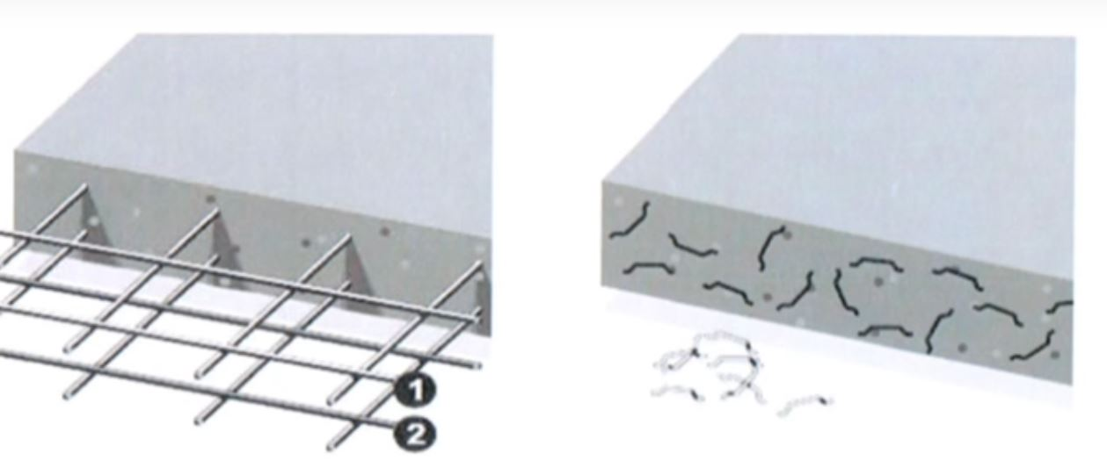
Figure 1.1 (a) Vibrated reinforced concrete -steel (b) Fibre reinforced concrete .
System building eliminates delays associated with material supply delays and weather
changes, hence the time that could have been spent on site, is time that the completed structure will be put into employ thus enabling landlords to make speedier returns on investment put into construction.
Arisoy et al. (2006) successfully developed high performance fibre reinforced
lightweight aggregate concrete using gypsum and that showed high flexural strength,
high flexural ductility, and excellent toughness. Recent years have realized a renewed curiosity in the development of lightweight materials due to the adoption of framed structure technology, where the walling comes in as an interlocking composite or solid panel.
This research brings together the employment of Fibre and Aircrete in an aim of achieving low cost and quality concrete by the effective reduction of material and labour costs coupled with overall construction time reduction. The general rate for private dwelling houses –{standard) can be put up at a cost of Kshs. 34,000 per square metre, (Institute of Quantity Surveyors of Kenya journal, 2017, 4th Quarter). As compared to Kshs. 25,000 per square metre, (Institute of Quantity Surveyors of Kenya journal, 2011, 4th Quarter).

Figure 1.2 Comparison of building construction price per square meter, 2011 vs 2017.

Problem Statement
The problems common to the Aircrete technology is it tends to be more bristle character similar to conventional concrete without reinforcement. Aircrete often called no-fines concrete, cellular concrete, aircrete or aerated concrete and lightweight aggregate concrete. (Islam, 2011).
My research ‘viability of Fibre reinforced Aircrete blocks as an alternative walling material in Kenya’. Among other problems being experienced is the cost of construction in Kenya has been continuously escalating and shows no signs of down any time soon, this coupled with the increasing need for housing makes a demand for an alternative building solutions, materials and better building methods that can provide tailor made solutions in the construction process.
The natural stones, due to their finite nature, their availability is diminishing and are not readily recyclable. The quarrying activities among other mining activities have contributed immensely to the environmental degradation, contradicting the global principle of sustainable. development (Goudie & Viles, 2013). Sustainable construction material that are friendlier to our environment
The other problem with the traditional walling materials is their characteristically high dead load which could be reduced by adopting lightweight walling elements. A reduction in the dead load exerted on a structure would result to slender structural members, hence making a significant contribution to the reduction of the cost of construction in Kenya.
Even though the demand for housing in Kenya is constantly on the rise, the solution put forth the in the industry today doesn't fully address the reality of demand in the construction market.
The number one killer of building wealth is high interest- rate debt. (Todd 2003). The middle class will spend most of their youthful days working to have a place they can call home. They are charged a high interest rates from the moment of mortgage acquisition, which is never the moment of house occupation. They are therefore charged an interest on a commodity cannot start using for a stipulated amount of time; the construction period. This research purposes to prove that system building using foam concrete panels for walling employed to guarantee a reduced period of time is spent on site, employing a small as workforce to achieve project completion for a comparatively lower cost, thus affording the prospective Kenyan home owner a chance at achieving their dreams, enable our government sustainable achieve the big 4 Agenda without falling under the burden of foreign loans.

Research Objectives
There is need, need for more affordable, sustainable and quality concrete to satisfy the housing shortage. This anchors my proposal on to investigate the viability of fibre reinforced aircrete blocks as an alternative walling material.
- To determine the optimum mix proportions of Fibre Reinforced Aircrete blocks.
- To compare the properties of the Aircrete blocks with conventional walling materials
- To investigate the reduction in the dead load in comparison with conventional walling materials
- To compare the results of Fibre reinforced Aircrete walling and other walling materials.
- To prepare and organize mix design charts and graphs to aid users for wide field performance and to abet a start for next researchers interested in fibre reinforced Aircrete in Kenya.

Research Questions
- What would be the appropriate mix proportions that will give an optimum fibre reinforced interlocking aircrete blocks?
- Why fibre reinforced Aircrete and not conventional concrete?
- What is the mix design to achieve a material for different purposes?
- Why Aircrete?

Justification for the Study
Aircrete has been used in many different applications for several decades, including buildings, monolithic structures, road bases to rural roads in India and in ancient times during Roman Architecture traces have been found in the columns. The adoption of this technology in the modern-day construction industry would lead to a significant drop in the cost of having a home for most Kenyans. The average Kenyan would need to work the better half of their works to afford to build a place or to pay up long term loans and consumes the youth earning just to have this vital basic human need. Just like food, and water shelter is vital and any sustainable innovations used to achieve the vision is a positive to the human race. With the problem of environment pollution being a major topic of discussion in most conferences, there is an urgent need to cut down reliance on natural occurring resources which are non-renewable and contributes immensely to the much-taunted environmental degradation. This research aimed at developing a construction material that is affordable, sustainable and quality.

Scope of Research
This study will have a momentous impact in the general construction industry as it will influence the major stakeholders' decision making in terms of ensuring sustainability in the projects undertaken. The information gathered and the recommendations made at the end of this research will be crucial for; the government agencies or rather anyone in policy-making, property developers in coming up with Big four Agenda of affordable housing.
As an academic requirement, its success will enable the researcher to partially fulfill the set coursework in order to attain the degree award.
In terms of the contribution to the training, the research will provide insight and knowledge to other professionals, students and even the people on the ground in the construction industry. At the end of this study, the recommendations made shall open.
The researcher intends to use this research as a test as an alternative to building blocks in the near future.

CHAPTER TWO

LITERATURE REVIEW

History and development of Aircrete
By the word “lightweight”, this type of concrete gives a simple indication that lower unit weight is necessary for being a lightweight concrete. However, in reality the definition is not that simple and not easy to categorize due to variety of lightweight concrete branches, origin, uses and production processes. The range of unit weight that can be referred as lightweight is also diverse. Neville (2000) suggested range of 300-1850 kg/m3. In addition to unit weight, another major commitment of lightweight concrete is applicability i.e. strength and thermal conductivity. Sometimes thermal conductivity is the prime requirement along with strength as seen from Dunaeva (2006).
Aircrete can be dated back to Roman empire during the construction of the pantheon as a way to reduce the loading on the dome and to displace concrete to create the tall columns. This construction material subsists and can be dated Roman Emperor Hadrian 117AD - to 138 AD in the Roman empire evidence being visible during the construction of the pantheon, a majestic temple built in honour for the roman gods, largest non-reinforced dome rising 150 feet and the 30 feet oculus (hole at the top) as a way to reduce the loading on the dome and to displace concrete to create the tall columns.
According to Oss (2010), about 2,840,000,000 metric tons of concrete was consumed all over the world in the year 2008. Concrete is well thought-out as a proper construction material for many infrastructure development. It is composed of cement (frequently Portland cement) as well as other cementitious materials such as fly ash and slag cement, aggregate (generally a coarse aggregate such as gravel, limestone, or granite, plus a fine aggregate such as sand), water, and chemical admixtures.

Conceptual Framework (Variables)

Portland Cement
In historical note by Neville (2000, p. 2),he mentioned that English engineer Joseph Aspdin patented Portland cement in 1824; The quality of cement has improved over the years. Cement acts as the binding agent in the mix that produces foam concrete. Portland cement sets hard and quickly, allowing a faster pace of construction, and requires less skilled workers.

Fibres
Three types of fibres will be used –Steel fibre from waste steel wires and synthetic fibre and bamboo fibre. Waste steel wires found as such constitute the main waste material found in the construction sites in which steel reinforcement as well as formworks were highly used. This The shear strength increases with increasing volume percentage of fibres. This is because of fibres enhances the load carrying capacity of mix. The percentage increase in shear strength of the mix varies from 27 % to 32 %. (Prof. Prit, 2011) Hence the adoption of fibre could prove to be effaceable to strengthen the Aircrete block to greater shear strengths.

Steel fibre
- Diameters vary from 0.25mm to 0.75 mm
- High structural strength, high modulus of elasticity
- Used in precast and structural applications, highway and airport pavements, refractory and canal linings, industrial flooring, bridge decks, etc.
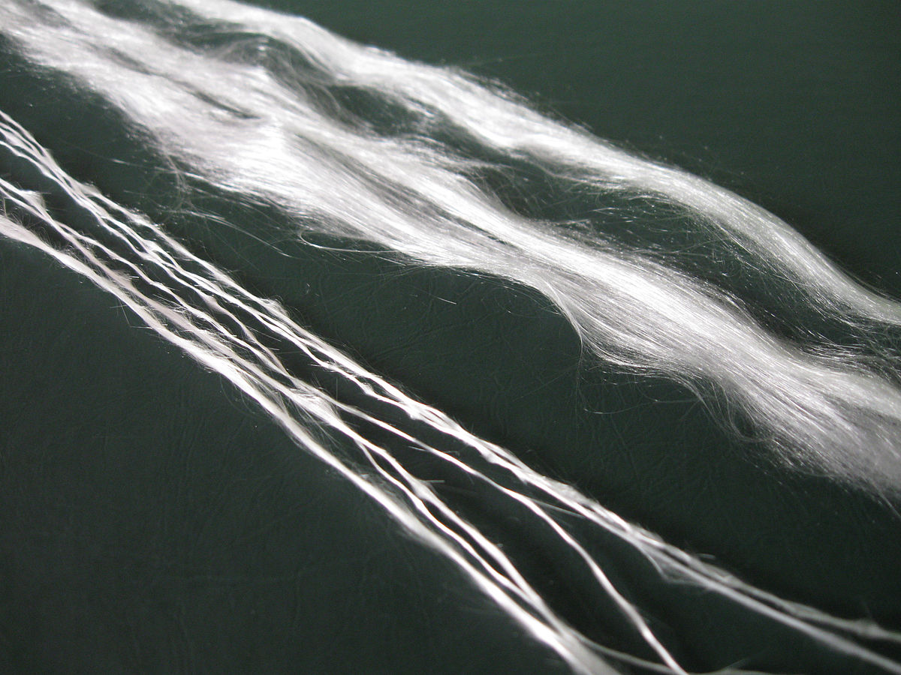
Figure 1. (a) Cut waste steel wires . (b) Synthetic fibre .

Synthetic Fibre
- Man made fibres from textile industries .
- High chemical resistance .
- Low modulus of elasticity .
- Cheap and abundantly available .
- Applications in cladding panels and shotcrete .

Natural Fibre (Bamboo).
The oldest forms of fibre reinforcement composites were made from natural occurring materials such as Bamboo, coconut fibres, jute fibres .
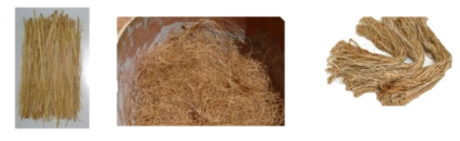
Figure 2.2 a) Bamboo fibres . b)Coconut fibres . c)Jute fibres .

Water
Potable water can be used for manufacturing concrete. The water-cement ratio (mass ratio of water to cement) is the key factor that determines the strength of concrete. A lower water-cement ratio will yield a concrete which is stronger and more durable, while a higher water-cement ratio yields a concrete with a larger slump, so it may be placed more easily. (Islam, 2011). Cement paste is the material formed by combination of water and cementitious materials; that part of the concrete which is not aggregate or reinforcing. of the aggregates. Normally excess water content causes as void in hardened aircrete reducing its integrity. However, this slurry composite of concrete has vast workability hence makes it a variable.

Theoretical Framework

Method of formation
Air-entraining also known as Aircrete, aerated concrete can be dived into two by their method of formation with air gaps being the main objective methods used to achieve this can be looked up as follows: -

Foaming method
This technique has been reported as the most economical, sustainable and controllable air bubbles forming process since there are no chemical reactions involved. The generation of air voids is attained through mechanical means either by pre-formed foaming or mix locally available forming agent with cement. The various aerating agents used are detergents, resin soap, glue resins, saponin and hydrolysed proteins such as keratin.

Acoustics
Solid Aircrete interlocking block will provide advanced performance regarding sound transmission from the exterior to the interior of the building, this is contribution of the air pores that provide great vacuum pockets to prevent the sound vibrations. However, distressed and open joints between members can provide a condition in which sound transmission to the interior may be increased.

Durability
Aircrete foam concrete system allow for addition of colour additives such as red oxide or white wash to give a more lasting colour that the designer tends to achieve. Blocks used in wall systems have many different finishes and shapes. Often the finish will include the abrasion or modifying of the surface by sandblasting, exposing aggregate, acid washing, bush-hammering, or other techniques.

Failure Potential
Concrete is a brittle in nature hence the use of reinforcement bars to reinforce the slab, cracks develop immediately after casting

Maintainability
When properly constructed fibre reinforced Aircrete blocks low maintenance. The most important maintenance item for prefabricated panels is that it is weaker compared as conventional concrete. It is impervious to termites, rodents, and pests Use of zinger paint is also a viable option as it is highly resistant to corrosion.

Moisture Protection
The most common moisture protection system used with Aircrete interlocking block systems is a barrier system incorporating an adequate joint seal. In some cases where additional moisture protection is needed, the application of a sealer or a concrete coating is also used. Sealers can be either clear or pigmented if used as an enhancement of the prefabricated appearance. Film-forming coatings usually offer a higher level of performance but will have a significant impact on the appearance of the fibre reinforced aircrete block foam concrete unit. Ability to resist moulds makes it a good at moisture control in painted surfaces.
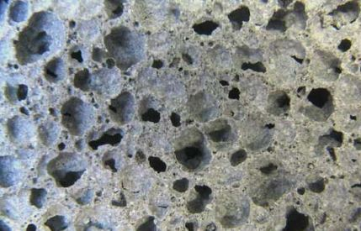
Figure 2.4 Aircrete pores .
(Source: International Journal of Civil Engineering, vol. 7, 2014)

CHAPTER THREE

RESEARCH METHODOLOGY

Introduction
In this chapter of the study, the core task is to describe how the researcher intends to go about the topic proposed in an effort to attain the intended objectives within the scientific parameters. This section describes; the research designs that will be adopted in carrying out the study, the nature and sources of data that will be collected; methods of collecting data and how the data will be analyzed and presented.

Research Design
Since this research is investigating the viability of fibre reinforced aircrete blocks as an alternative walling element, and, therefore, there is need to know the optimum properties through practical experiments, the experimental design approach was used throughout to obtain quantitative data. Experimental design approach method will be used for the production of the sample specimens which will then be exposed to various tests in an effort to measure their properties. The experiments will be carried out in the Jomo Kenyatta University of Agriculture and Technology laboratory.

Materials

Fibres
Three types of fibres will be used –Steel fibre from waste steel wires and synthetic fibre and bamboo fibre. Hence the adoption of fibre could prove to be effaceable to strengthen the Aircrete block to greater shear strengths.

Steel fibre
Figure 1. (a) Cut waste steel wires; (b) Synthetic fibre

Synthetic Fibre
- Man-made fibres from textile industries .
- High chemical resistance .
- Low modulus of elasticity .
- Cheap and available.

Natural Fibre.
The oldest forms of fibre reinforcement composites were made from natural occurring materials such as Bamboo, coconut fibres, jute fibres .
Figure 2.2 a) Bamboo fibres, b)Coconut fibres c)Jute fibres

Mixture composition
Fibre Reinforced aircrete is the volumetric mixing of cement, fibers, water, polystyrene evenly sized foam air pockets.

Preparation of Fibre Reinforced Lightweight Aircrete,
Water and foaming agents will first be mixed in a bucket for three minutes. Then addition of added gradually at a polystyrene beads to cement ratio of 20 g per every 1000g of cement, mixing will continued for another minute. The researcher will ensure the mixture is thoroughly mixed ensuring cement does not settle at the bottom of the container and all Alongside the continuous addition of fibres and polystyrene beads a spontaneous effort was made for prevention of fibres getting clumped. This phenomenon suggested that polystyrene beads if not mixed mechanically with foam and viscous admixture might result in non-homogenous mass. Other than above disadvantage, polystyrene beads gave soft texture in the surfaces allowing punching by finger or nail. (Islam, 2011).
Figure 3.1: Typical preformed foam generator
ASTM C39. Generally, 6 samples of fibre reinforced aircrete will be cast in cube moulds. These were greased with diesel prior to batching to facilitate the samples’ removal. The moulds will then be removed at about one day after batching, and the first samples broken. Three cubes were broken at each testing time, unless they will be less or more samples or one of the samples failed as a result of an obvious defect, in which case the result must be thrown out. The cubes will be tested in a universal testing machine.
The moisture content will be gotten by;
$$A=\frac{B-C}{C-D} x 100\%$$
Where;
A = Percent moisture
B = Mass of original (wet) sample
C= Mass of dry sample and container
D = Mass of container

Unit of Analysis
The study adopted the use of the American Society for Testing and Materials and the British Standards as the benchmark for acceptability for tests to be performed on the specimens.

Nature and Sources of Data
The data collected was quantitative due to the nature of the study undertaken by the researcher which is experimental.

Primary Sources
The primary data was obtained from laboratory tests: the data obtained included the mix proportions of aerated concrete; the engineering properties of the specimen and the weights of the units.

Secondary Sources
The data for this research was obtained from books, journals, magazines and internet sources. These sometimes helped in understanding the theory behind the mix proportions and its properties. They also provided information regarding the applications of aircrete concrete in the construction industry and for the definition of important terms associated with the topic of the paper.

Data Collection Methods and Instruments
Data collection for the proposed project was collected from experimental observations in the workshop and laboratory tests.
Measurements- this involved taking readings and weighing where called for.

Collection of Primary Data
The research design is purely experimental and so the method of primary data collection will be observation of the experiments to be carried out.

Sampling Methods
The prepared specimen in the case of laboratory experiment shall be categorized into three strata.
The first strata shall be tested for the optimum mix proportions of preparing fibre reinforced aircrete concrete blocks. The second strata shall be tested for the curing period and finally the third strata, this shall be tested for the dry density in comparison with the conventional walling elements.

Collection of Secondary Data
This will be collected through published research works, Internet, journals, books, government publications.

Data Analysis
After the collection of data, the analysis was performed using different tools, for instance, Excel, Photos, Graphs, and Tables.

Data Presentation
For any collected and recorded data to be meaningful and achieve the intended objective it has to qualify in terms of relevance at a glance and make ease and comparison, the following data presentation techniques are proposed to be used:use of tables; graphs and photographs.
PROPOSED RESEARCH BUDGET
ITEM | Resources | Quantity | Estimated cost
A | Cement | 1 bag | 850
B | Foaming agent | 5 litres | 750
C | Synthetic Fibre | 200 grams | 250
D | Transport | Item | 1000
F | Labour | Item | 1500
G | Foam gun making | Item | 1000
I | Airtime and Internet | Item | 500
J | Contingency | Item | 2000
Total |  |  | 7,850/-

EXPERIMENTAL PROCEDURE

Materials Required

Sand
One key ingredient for manufacturing of Aircrete blocks is silica-rich material like fly ash, pond ash or sand. Due to availability reasons the researcher will used sand. Finely ground sand with silica (S102) content not less than 65% is mixed with water to form a slurry. Finer sand reduces the processing time and increases the compressive strength.
Material | Quartz | Fused Silica
Density (g/cm³ ) | 2.65 | 2.2
Thermal Conductivity (Wm-1K) | 1.3 | 1.4
Thermal expansion coeff.(10⁻⁶K⁻¹) | 12.3 | 0.4
Tensile Strength (Mpa) | 55 | 110

Limestone powder
Limestone powder acts as the main binding agent in the aircrete blocks.
Molecular Weight (g/mol.) | 100.09
pH (Saturated solution) | 9.3 to 9.8
Loose Bulk Density(lbs/ft²) | -35-58
Loose Bulk Density (lbs,/cu. ft²) | 50 to 90
Tapped Density (g/cm³) | 0.43 to 0.98
Specific Heat (Btu/lbs./deg.F) | 0.19

Portland Cement
NguvuTM 32,5N Pozzolanic Cement Was acquired by {he researcher from a reputable distributor packaged, it came in 50kg airtight bags. The chosen brand of cement conforms to BS EN 197-1 : 2000 hence giving it the required validity in terms of standards.
Chemical Composition of Portland Cement
Portland Cement | %
Silicon Oxide SiO² | 19.81
Aluminium Oxide, Al²O³ | 6.01
Iron Oxide, Fe²O³ | 2.58
Calcium Oxide, CaO | 64.83
Magnesium oxide, MgO | 1.04
Sulphur trioxide | 3.26
Sodium Oxide, Na₂O | 0.18
Potassium oxide, K₂O | 0.91
Chloride, Cl | 0.016

Mix Proportions of the materials
The mix proportions of the sample blocks are shown in the table below for the of guiding the researcher though 36 blocks (1m³) was prepared with a little variation in the outlined proportions:-
Name | Unit | Samples To be Prepared – 36blocks |  |  | Total
 | % | 1st | 2nd | 3rd | 36 blocks
Sand | % | 60 | 60 | 60 | 440kg fine sand
Cement | % | 10 | 20 | 20 | 64kg
Limestone powder | % | 20 | 30 | 30 | 130kg
Gypsum | % | 1.5 | 1.5 | 1.5 | 30kg
Water | % | 10 | 15 | 20 | 72 litres
Aluminium powder (600kg/m³) | 1/10000 | 8 | 8 | 8 | 250grams
Synthetic fibre | grams | 150 | 150 | 150 | 3cm long

Apparatus

Molds
The mix will be cast in iron molds. For compressive strength test the mix was cast in iron molds measuring 150x150x150mm and others measuring 100 x l00 x 100mm. Sample specimen subjected to Flexural test were cast in molds measuring 550x l50x150mm.

Measuring Apparatus
Different apparatus will be used throughout this research. However, the main ones: Weighing machines; for smaller weights like the weight of aluminium powder, calcium sulphate, electric weighing balance machine will be used for significantly bigger weights, for instance, the weight of Silica, Lime and Cement, platform weighing machine was used; linear measuring apparatus included the measuring tape,

Ventilated Oven
A ventilated oven thermostatically controlled and capable of maintaining temperatures of (80 ± 2) ⁰ C will be used for the successful drying of the test specimen.

Curing Tank
A curing tank located outside the Engineering Annex Lab (Jkuat) will be used for curing the sample specimen. The temperature of the water the curing tank was maintained at 20±2⁰ c

Mixing trough
The trough will be used as a place for mixing the variables before casting them. The material should not react with the mixed variables.

Universal Testing Machine (UTM)
This machine will be used for testing the compressive strength of the sample specimens.

Flexural Strength Testing Machine
A two-point flexural strength testing machine used for determining the flexural strength of the aircrete specimen used as a walling element.

Type of experiment | Sample shape | Sample size
Compressive strength test | Block | 0.4m³
Dry density | Block | 0.4m³
Water Absorption | Block | 0.4m³
Compressive strength test | Walling Element | 1m³
Flexural strength test | Block | 0.4m³

Production Flow Chart
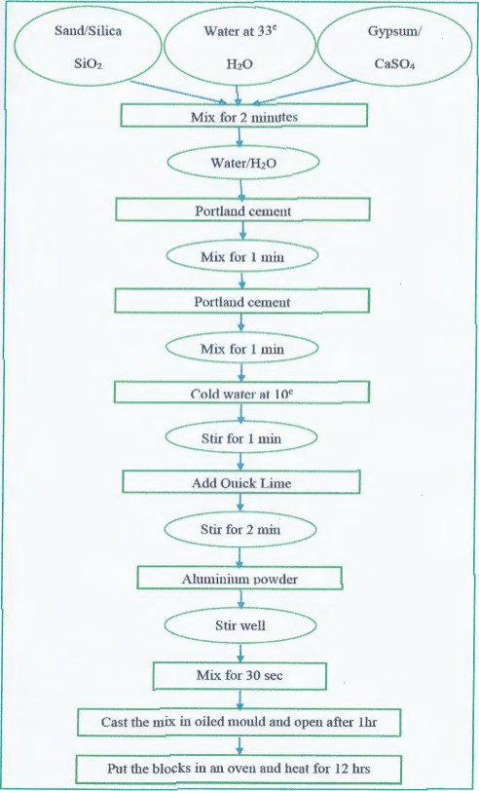

Schedule of Works
SCHEDULE OF WORKS
Stage | Works | Duration | Date
Stage 01 | Preparation of samples | 2 days | 13th & 16th May
Stage 02 | Curing Tank | 21 days
Stage 03 | Day 28 Tests (Compressive strength, Flexural strength, Water Absorption, Initial rate of absorption) | 3 days | 17th June
Stage 04 | Data Anaylsis | 1 day | 18th June
Stage 05 | Data Presentation | 1 day | 19th June 2019

Research Objectives
There is need, need for more affordable, sustainable and quality concrete to satisfy the housing shortage. This anchors my proposal on to investigate the viability of fibre reinforced interlocking aircrete blocks as an alternative walling material.
- To determine the optimum mix proportions of Fibre Reinforced Aircrete blocks.
- To compare fibre reinforced aircrete block with conventional walling blocks
- To investigate the reduction in the dead load on a structure as a result of using Aircrete blocks.

RESULTS AND DISCUSSIONS

Introduction
The data to be analysed and presented was highly gotten from various laboratory tests conducted. Both the qualitative and quantitative approaches were embraced in analysing the data depending on their nature and type.

Discussion of Objectives

To determine the optimum mix proportions of Fibre Reinforced Aircrete blocks.
Aircrete blocks were prepared with varied proportions of the constituent materials. This was deliberately done but in close adherence to standards and the literature review done. To achieve a credible product worth of being adopted in the construction of safe housing, there is a need to carry out experiments and testing to verify the suitability of the end product. Different specimens of varied mix proportions were prepared and later subjected to testing. Those found to attain the desired characteristics and as per the laid down standards, were concluded to be viable options worth of consideration and was used to create a wall for further tests.

To analyse the properties of the Aircrete blocks as a walling material
The prepared specimens were tested to check on the necessary engineering properties. For instance: were determined and checked. against the standards. The acceptance and rejection of the properties exhibited by the specimens tested.

To investigate the reduction in the dead load on a structure as a result of using Aircrete blocks.
The dry density of a product is directly proportional to the dead load exerted on any structure. Aircrete has been daunted as a lightweight material, for this reason it's vital to determine the density and make a comparison with the conventional masonry units in order to gauge the proportional reduction in the dead load on a structure..

Initial Rate of Absorption

Results
The table below shows the results obtained from the initial rate of absorption test conducted in the laboratory.
Table 5.0: Table of Results for IRA
Specimen | Area | Dry weight | Wet Weight | IRA
B1 | 0.4 | 12.6 | 12.7 | 1.58
B2 | 0.4 | 10.567 | 10.619 | 1.52
B3 | 0.4 | 8.79 | 9.882 | 1.49
Average IRA on the 7th day |  |  |  | 1.53
B1 | 0.4 | 10.80 | 10.88 | 1.9
B2 | 0.4 | 10.35 | 10.42 | 1.8
B3 | 0.4 | 10.04 | 10.124 | 2.0
Average IRA on the 14th day |  |  |  | 1.9
B1 | 0.4 | 9.01 | 9.10 | 2.0
B2 | 0.4 | 8.63 | 8.70 | 1.9
B3 | 0.4 | 8.37 | 8.46 | 2.1

Specimen | Area | Dry weight | Wet Weight | IRA
B1 | 0.6 | 15.90 | 17.40 | 2.50
B2 | 0.6 | 15.40 | 17.24 | 2.82
B3 | 0.6 | 14.50 | 16.40 | 3.17
Average IRA Machine cut stones randomly selected |  |  |  | 2.83

Figure 5.0: IRA bar chart analysis

Discussion

From figure 5.0 above the following observations were made; the initial rate of absorption on average decreases with the amount of Water percentages The fibre reinforced aircrete blocks have much lower IRA than conventional Ndarugo blocks collected from local mine, however, from the literature review the optimum recorded initial rate of absorption was 2.28Kg/m²/min (T M Prakash, 2013).
For further understanding of the initial rate of absorption masonry units, According to A.B Wafula, 2015 the IRA recorded from existing literature due the limitation of the scope for this research. Table 5.1 shows the recorded initial rates of absorption for other conventional walling blocks:-

Table 5.1: Initial rate of Absorption of different walling blocks
Walling block | IRA (Kg/m²/min)
Fibre reinforced aircrete blocks(28th Day Test) | 2.0
Table moulded Brick | 3.7
Solid concrete block | 4.1
Hollow concrete block | 1.6
Stabilized Mud Brick | 2.4
Ndarugo blocks | 2.8
Figure 5.1: Comparison of IRA of various walling blocks analysis

Discussion
The initial rates of absorption of conventional walling blocks that were compared with fibre reinforced aircrete blocks were not determined in the laboratory by the researcher but were rather obtained from existing literature, this was due to the financial and time constraints.
From figure 5.1, It can be noted that the initial rate of absorption values of fibre reinforced aircrete blocks is less than that of conventional solid concrete block masonry unit. The phenomenon is as a result of larger porosity and capillary action, while the pores in aircrete units are discontinuous, through well dispersed contains small air pockets.

Compressive Strength test

Results
Table 5.2, below shows the values of Compressive strength for fibre reinforced aircrete specimens which were produced by using different percentages of water.
Figure 5.3 Water Percentage Vs Compressive strength,
Specimen | Area | Dry weight (Kg) | Load (KN/m³) | Compressive Strength (MPa)
B1 10% | 0.4 | 12.6 | 132.511 | 3.264
B2 15% | 0.4 | 10.567 | 155.725 | 3.878
B3 20% | 0.4 | 8.79 | 160.117 | 3.940
Water % Vs Compressive strength, on the 7th Day |  |  |  | 3.694
B1 10% | 0.4 | 10.80 | 111.772 | 3.753
B2 15% | 0.4 | 10.35 | 137.824 | 3.694
B3 20% | 0.4 | 10.04 | 107.019 | 3.890
Water % Vs Compressive strength on the 14th day |  |  |  | 3.779
B1 10% | 0.4 | 9.01 | 177.848 | 4.805
B2 15% | 0.4 | 8.63 | 154.185 | 3.812
B3 20% | 0.4 | 8.37 | 121.517 | 3.129
Water % Vs Compressive strength , on the 28th Day 151.183 |  |  |  | 3.961
Plate 5.0 Compressive strength reading Sample

Discussion
It was noted:
- The strength decreases when the percentage of water increases, which means the strength of aircrete depends with the amount of air bubble , the more the air pores the lighter the block or the weaker the sample blocks.
The strength of Aircrete increased proportionally with the increase in the percentage of aluminium powder and water percentages by weight, from 1% there was a reduction in strength the adding of aluminium powder, the aircrete concrete specimens underwent sufficient reduction in their compressive strength. Thus, the reduction in strength increases with increasing proportion of aluminium powder, and the compressive strength is very low when the measurement of aluminium powder reaches to 2% by weight of cement. With this kind of behaviour, it is worth noting that there is an optimum level of aeration that would be required in order to achieve optimal strength and this optimum percentage of water by replacement would be 1% as brought out in the graph.

Comparison of compressive strengths with conventional walling blocks
Table 5.4: Table of Results for Natural cut stones Compressive strength
Specimen | Block | Dry weight (Kg) | Load (KN/m²) | Compressive Strength (MPa)
B1 | 400X200X200 | 12.01 | 79.428 | 1.681
B2 | 400X200X200 | 14 | 143.785 | 3.572
B3 | 400X200X200 | 15.00 | 201.880 | 4.273
Compressive strength (Average) 141.478 |  |  |  | 3.175

Comparison of Density of fibre reinforced aircrete blocks with other walling blocks.
In order to compare the reduction in load of aircrete concrete blocks relative to other conventional masonry units, the researcher through literature review gathered the dry densities of various walling blocks. Dry densities of the chosen conventional masonry units could equally have been determined in the laboratory except for this case where time was a limiting factor. tables below outline dry densities of walling elements:-

Table 5.4: Comparison of Aircrete with Conventional units
Walling Block | Density
Fibre Reinforced Aircrete blocks | 1688
Solid Concrete blocks | 2400
Ndarugu stones | 2200
Common Red bricks | 1922

Figure 5.4: Comparison of Aircrete with Conventional units

Discussion
Fibre reinforced aircrete blocks is significantly less dense as compared to other conventional masonry blocks. For instance, The Aircrete with more reaction where known as percentage of water give a lighter block to be specially made to adapt to different demands considering that the gypsum give the Aircrete block mature stronger with time just like clay bricks would drastically translate to a decrease in the deadweight exerted on any structure.

Comparison of the structural performance of the conventional types of walls.
The result of panel wall tested in axial compression are presented in this chapter. Fibre reinforced Aircrete wall were built, cured and tested at 28 days. Water percentage of 10 percent was used to make the wall; wall two was data retrieved from literature review built with the clay bricks from Kenya Clay product and wall three were data retrieved from literature review with the conventional stone blocks from Juja, Kenya. The walls were loaded up to the maximum load that leads to failure. The main objective of the compressive test was to compare the structural behaviour of the wall. For the entire wall, the proportion of mortar mix depended on compressive strength of each brick and block corresponding to the table 5.9, BS 5628. The clay wall had a dimension of 600 x 800x 155mm while the conventional Ndarugo stone blocks wall has a dimension of 600 x 800 x 140mm and Aircrete wall has a dimension of 800 x1000 x177 mm. Table 5.10 below shows the dimensions of the tested walls, strength of blocks and mortar mix proportions.

Flexural strength of fibre reinforced Aircrete Wall
Table 5.9 below shows the results from flexural strength performed for percentage proportional composition ranging from 0 to 100% at 28 days.

Table 5.9: Flexural strength of Aircrete brick wall at 28 days
Sample  Marking(  % of Water) | Casting Date | Testing date | Age  (days) | Load (kN) | Crushing  Strength  (Mpa) | mold size (mm³)
10% | 16/5/2019 | 17/6/2019 | 28 | 2.7 | 0.5728 | 40x40x160

Table 5.10: Flexural strength of natural stone ( Ndarugo )
Sample | Weight (g) | Load (kN) | Crushing strength (MPa) | Size
 | 17000 | 7.637 | 0.614 | 40x40x180
 | 17000 | 6.004 | 0.482 | 40x40x180

Compressive capacity of walls
Figure 5.8 below shows the maximum stress of each wall. The stress was calculated using the relation in equation below;-
C_{D} =W_{D}/A
Where:
C_{D} = Compressive strength in N/mm²
W_{D} = Total load at which the dry specimen was failed in Newtons
A = the surface area on which the load was applied in mm²
Table 5.8: Maximum compressive strength of walls
Designation | Compressive Capacity (N/mm²)
Fibre reinforced Aircrete Wall | 1.72
Clay Wall | 0.64
Natural stone Wall / Ndarugo blocks | 1.98

0.0
1.0
1.5
2.0
Fibre Reinforced Aircrete
Wa1lllllljjhgl1ll
Clay Wall
Natural stone Wall
Maximum Average stress
MPa
(

Wall designation

Figure 5.8: Maximum stress in the walls
The maximum stress in each type of wall was 1.7 N/mm², 0.64 N/mm² and 1.98 N/mm² respectively for fibre reinforced aircrete wall, clay wall and natural stone wall as presented in Figure 5.8
It was observed that the maximum compressive stress of the walls was lower than that of the individual bricks. Hemant &al, (2007) examined the relationship between the compressive strength of a masonry and the brick units. This means that Ndarugo walling has an average higher compressive strength than fibre reinforced aircrete wall and brick.
The current situation is similar to that of Hemant & al.(2007), They suggest that the composite nature of the masonry wall reduces the ultimate load carrying capacity of the wall. Making a brick to have slightly higher strengthen than a wall ultimate loading capacity.
The wall made of Ndarugo blocks gave the highest strength however; the unit weight of its unit block is higher than aircrete wall. This is mainly attributed to :
- The depth of mortar to obtain the desired height of wall, which was 750mm was different for each wall.

Failure patterns of walls
Plate 5.1 below shows some transversal cracks on faces of fibre reinforced wall. This failure was based by shear force and was due to the combination of tensile cracks parallels to the axis of loading and shear failure along lines of weakness.
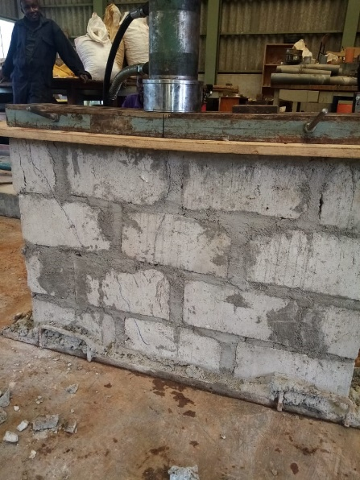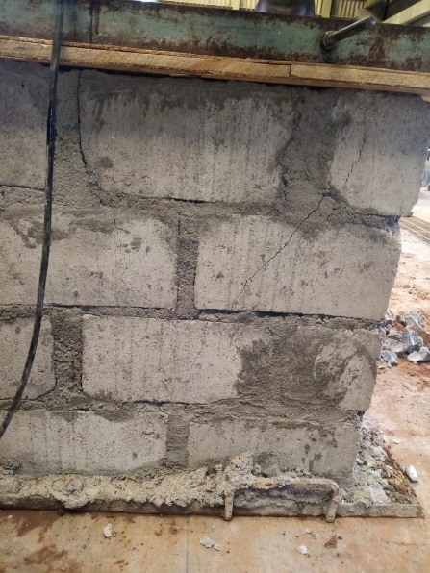

Plate 5.1: Failure patterns of Fibre reinforced aircrete wall (Source Author)

CONCLUSIONS AND RECOMMENDATIONS

Introduction
The key objective of this research study was to determine the optimum mix proportions of Fibre Reinforced Aircrete blocks.
To investigate the properties and structural performance comparing fibre reinforced aircrete block with conventional walling blocks.
To investigate the reduction in the dead load on a structure as a result of using Aircrete blocks.
Afterwards a comparison of strength properties (compression and flexural strength) of these bricks was done with those available in the Kenyan market. Finally, the Aircrete wall was structurally tested and compared with natural stone and clay bricks walls.

Conclusions
- The investigation done in varying percentage of water composition in Aircrete bricks shows that as the proportion of water increases, the physical and mechanical properties of bricks become weaker.
- In comparison with the blocks used in the local market, it is found that Fibre reinforced aircrete with 10% of water content is the viable replacement as alternative blocks in terms of its strength properties and weight properties. The increase in air bubbles in the block means that it is much weaker.
- The walls constructed with Ndarugo blocks performed slightly better structurally than those made with Aircrete and performed better than some of the Ndarugo blocks which were tested.
- It was noted that Aircrete has lowest weight to volume ratio than other compared walling blocks available in the market.
- Fibre increased the overall properties of aircrete as increased strength against the bristle nature of Aircrete

Recommendations
From this study, it is recommended that:
- To strengthen our government vision on housing Big 4 agenda in the Kenya, the fibre reinforced aircrete blocks with the varying percentage of water to suit different needs be used for partitioning and unexposed works.
- To use the fibre reinforced aircrete blocks as an external wall it is necessary to use a good mortar which has better waterproof properties.

Areas of Further Studies
- Further research work should be carried out to establish the effect of environment use of fibre reinforced aircrete bricks.
- Use of fibre reinforced aircrete for Monolithic composite construction such as dome homes.
- Aircrete as a Road base in Kenya as compared to

PICTORIAL HISTORY (SOURCE – AUTHOR)
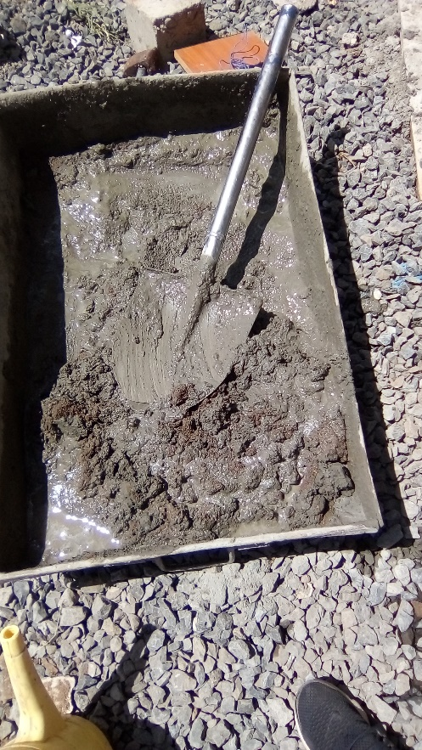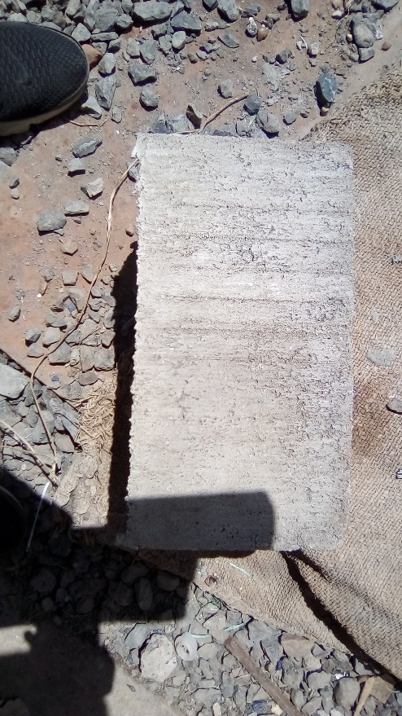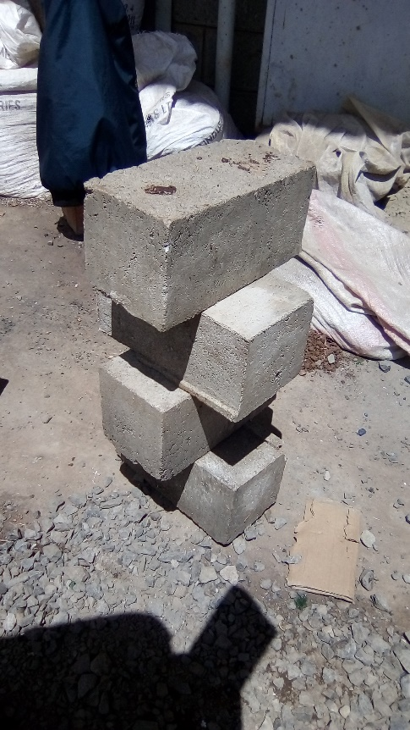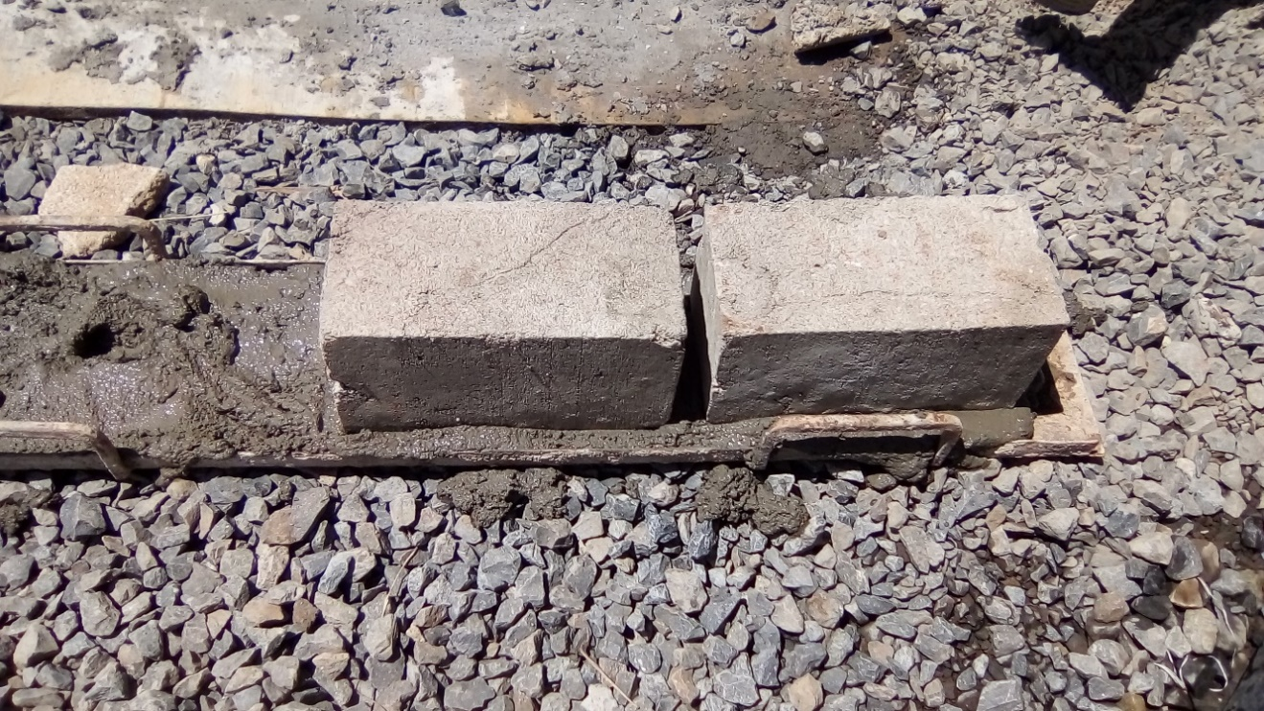
Pic 01. Mixing Trough Pic 02. Surface of block
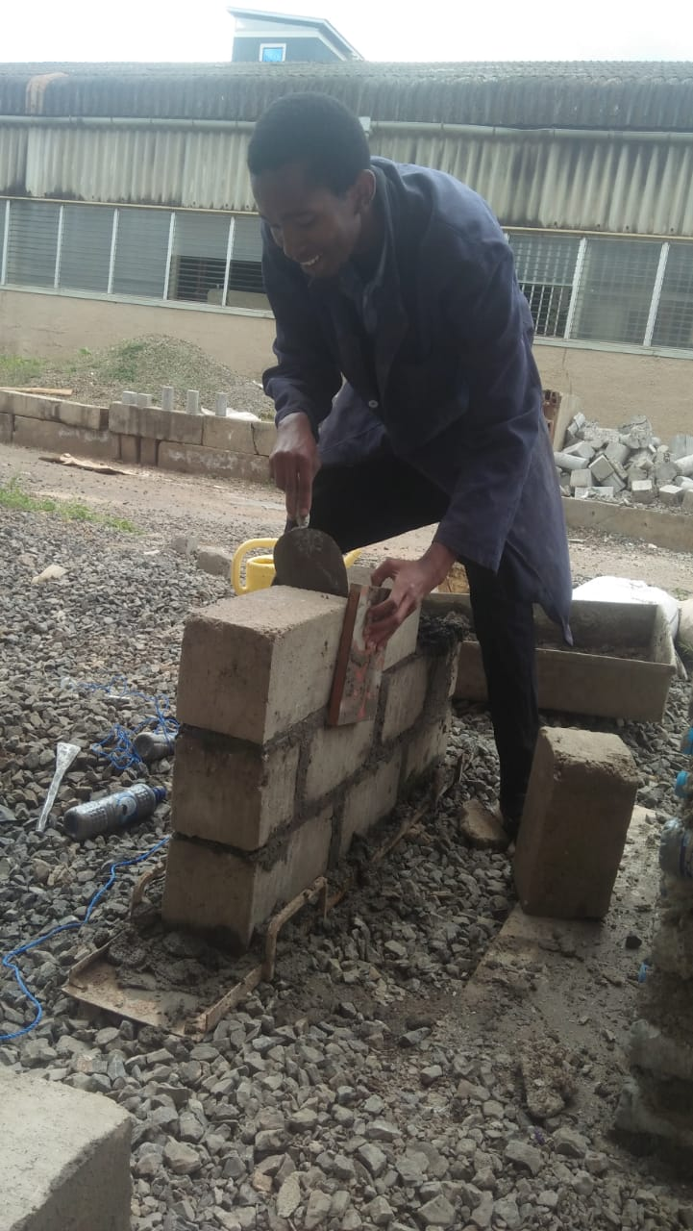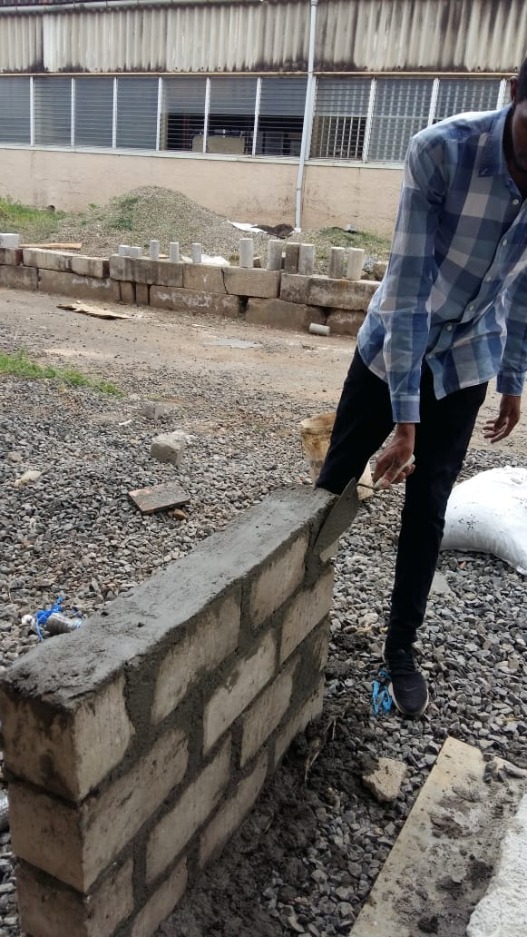
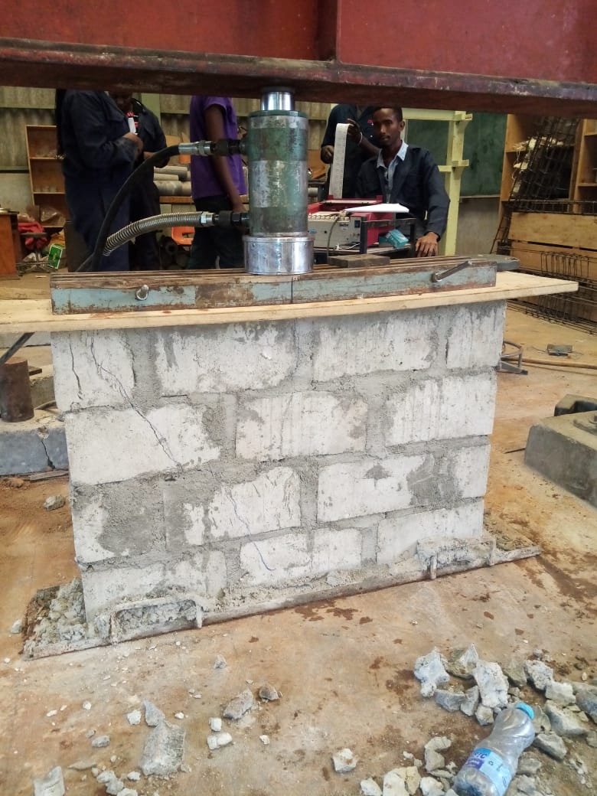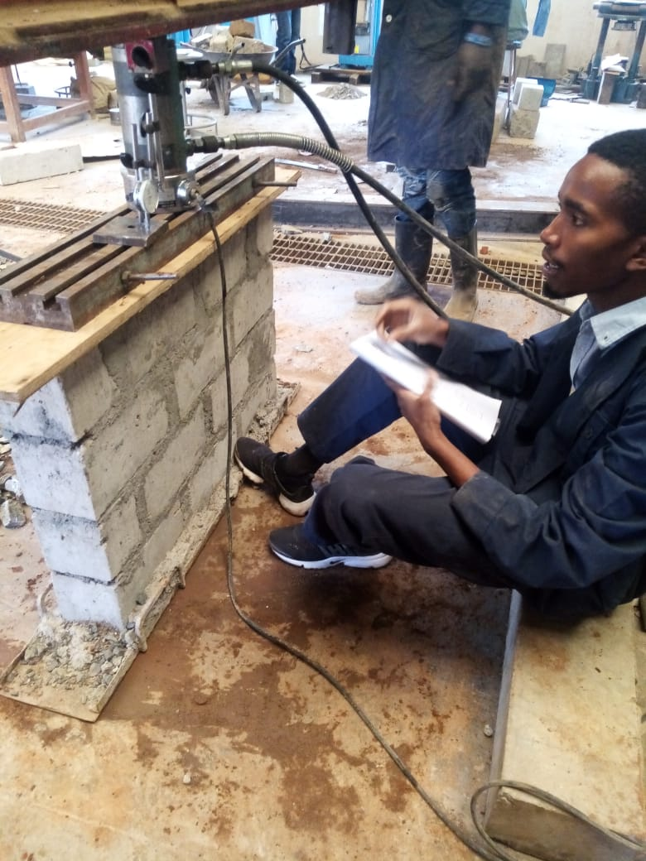

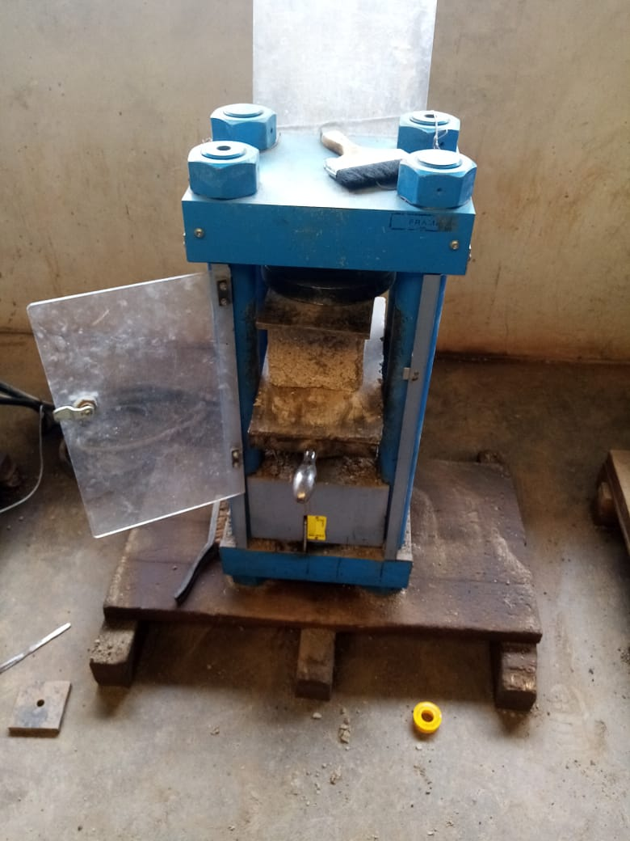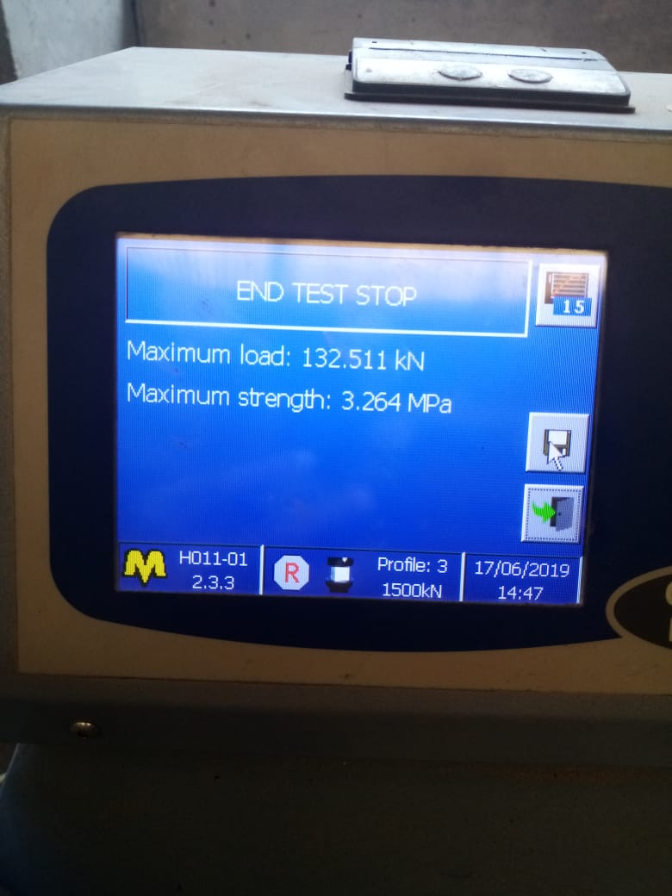

APPENDICES
Appendix A: Sieve Analysis of sand
Sieve size | Wtcumul retained | % Retained | % passing
10 | 5.17 | 0.52 | 99.48
5 | 35.50 | 3.55 | 96.45
2.36 | 79.17 | 7.92 | 92.08
1.18 | 321.67 | 32.17 | 67.83
0.6 | 645.17 | 64.52 | 35.48
0.3 | 804.83 | 80.48 | 19.52
0.15 | 965.33 | 96.53 | 3.47
Pan | 992.33 | 99.23 | 0.77
Total

Table F1: Load-displacement values
aircrete Wall | Displacement (mm) | 0.07 | 0.56 | 1.00 | 1.22 | 1.59 | 1.78 | 2.26 | 3.22 | 3.93 | 4.63 | 5.22 | 5.59 | 6.15
aircrete Wall | Load (kN) | 1.92 | 6.56 | 13.6 | 19.04 | 27.68 | 30.72 | 38.56 | 46.24 | 51.52 | 58.24 | 68.32 | 78.08 | 92.16

Table F2: Stress strain vertical
aircrete Wall | Strain  (10⁻⁶)  Stress  (MPa) | 0.47 | 0.47 | 0.00 | 0.00 | 0.47 | 0.94 | 0.94 | 0.94 | 0.94 | 0.00 | 0.00 | 1.42
aircrete Wall | Strain  (10⁻⁶)  Stress  (MPa) | 0.02 | 0.08 | 0.16 | 0.23 | 0.33 | 0.37 | 0.46 | 0.55 | 0.61 | 0.69 | 0.81 | 0.93

